Web Application for Fake News detection

Authors
Moipone Kabai 215203569
Mkalai Siphelele 220042926
Msomi Sebe 216028604
Ncubukezi Bongeka 215180925
Tshizana Busiswa 209057181

Abstract— Social media has allowed people the ability to exchange information at a much greater pace, which also allowed cybercriminals to quickly use the Covid-19 pandemic as an opportunity to launch attacks in vulnerable environments, to a far wider audience than ever before. However, this information is not always truthful.

discoverability

We have realized that fake news is excessively growing on social media platforms. The aim was to thoroughly research this concept while outlining how these news spread and why. We then discovered that the most obvious reasons for this is that everyone feels entitled to sharing their own version of the story and no one ever face legal actions for deformation. Our aim was to try and decrease this terrific rise of these deceptive news, by developing a web application that will be user friendly and not require any form of training before end-user could interact with it. After developing and testing the application, we discovered that 40% of news posted on social media is false.

introduction
Many people now get news from social media sites and social networks of which it can be difficult to tell whether stories are credible or not especially when fake news gets more attention than real news. Social media is an interactive computer-mediated technology that facilitates the creation and sharing of information, ideas, career interests and other forms of expression via virtual communities and networks. Daily or at least most of the time we use social media to acquire information. Examples of social media platforms include. Facebook, YouTube, Twitter, LinkedIn, Instagram and many more.
In the process of using these social media platforms, we often lose focus on why we chose to use them in the first place. This is usually caused by the need for popularity which influences so many things, like the content shared amongst these platforms. Sensibly, people use social media to network and stay in touch with others, to stay updated with news and current events, for entertainment and many more. It is very interesting how most of the top reasons are all linked to what we call ‘passive networking’ – that means users who come to social media to consume content rather than actively contributing to the stories. Most of the information consumed from the media is secondary, meaning that it is not the true version of the story, or at least what we believe to be factual.
Our aim is to try decrease this terrific rise of these deceptive news by developing a web application that will be user-friendly and not require any kind of training before the end-user could interact with it. Our application will have a search box where any title of an article, blog, or journal could be typed in for searching the probability of that information being true. For example, if a user types ‘Drug use in Cape Town and the author name’ and enters search, it should retrieve the article title, next to it the probability of it being false.

related work
Algorithms are ought to bring programming solutions. However some outcomes of different algorithms especially object orientated programming ought to bring different outcomes in which relatively in our scenario is designated to detect fake news and real news. As typically fake news is intentionally created to spread misinformation, their writing style slightly differ from that of reliable content. Therefore, the traditional approach to detect false content is based on linguistic features. Until now, one of the top classifiers relying on these features achieved the accuracy of up to 76% (Perez: 2017). Using relationships between news article, its creator, subject and fake/true label, it is possible to achieve accuracy.
A news article is often accompanied by visual materials like images or videos, which are rarely taken into account. Nevertheless, recent studies revealed that fake and real news exhibit different image distribution patterns. Some people proposed several visual and statistical features supporting the detection of fake news, however in our case we have not made use of visuals to extract information instead we only made use of text and links as images may be altered and our algorithm does not cater to detect that type of data. Another common approach is a browser extension alerting users about unreliable news source, is simply based on a curated open-source database containing an assessment of online information sources. We observed that some of the already unmasked pages that deliberately publish fake content use redirection to different URL, so there is an overwhelming need to update this database regularly. While detecting false content, the initial step should involve the assessment of source credibility.

the problem

Our domain area of the problem is the spread of Covid-19 fake news, mostly on social media. Social media has allowed people the ability to exchange information at a much greater pace, to a far wider audience than ever before. However, this information is not always truthful. Since we have found out that more consumption of news was though the corona virus pandemic, the spread of COVID-19 fake news aroused on social media.

In our communities this excessive rise of fake news has had a bad impact where by people were scammed through applications of RDC grant. Their personal information like identity numbers, contacts, addresses were gathered. Cybercriminals have quickly adapted to use the Covid-19 pandemic as an opportunity to launch attacks in vulnerable environments. For instance people were given links for Covid-19 “youth brigade” recruitment, learner-ships to send their documents, all in the name of scamming. There was also helpline claiming that it provide food parcel, where people would be asked to provide their details (name ID number and their income)in order to provide them with food parcels while they were going to use their details to do fraud.

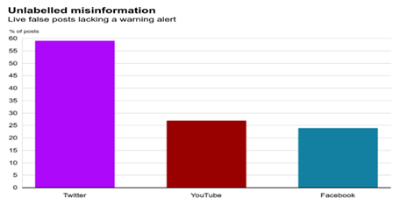 FIGURE 1. The bar graph above shows that how fake news about Corona virus spread through social networks.

A WhatsApp video that was misleading people to deny to test because it claimed that testing kits are contaminated with the virus, and vaccines are being tested on Africans only to kill them, voice note circulating claiming that one recovered after drinking the Old Brown Sherryl alcohol which was not true. After all these harmful issues, we have decided to raise awareness about fake news so that people can be able to determine and differentiate when something is real or fake.

We have therefore decided to design a web application that will detect whether news are true or false to help eliminate the spread of fake news on social media that is misleading people to be victims of such horrible incidents. By creating this application we will not only be raising awareness, but we will also be sharing knowledge and eliminating the knowledge gap within the digital space where news are concerned.

idea
We have decided to create a web application because we are a digital generation therefore news travel faster through social media platforms. The motivation behind this is the new laws about the impact of fake news. The main objective of our research is to implement a solution that will fact-check information on social media before allowing publication, where misinformation will be collected and tracked and denied publications where necessary. This will help everyone who has once been affected by fake news to know best next time, and also the future generation to be able to identify what’s real, and fake on the media.
PRE-CONDITIONS
Before developing our application, we need to know if this application is feasible or not, which in this case it is. We conducted a research briefly about fake news in general and specifically about Covid-19 news so that we may have a clear understanding of what is factual, so that it will be much easier to detect what is untrue.
We needed the equipment and enough resources to develop. This includes machines and resources suitable for software development, good programming language, and good testing skills.
Our application should have required a user to be registered to the application before they can be able to access the services provided, but as on the constraints, that was not developed. The data that we used to prove whether the data searched by users is true or false should be scientifically proven because Covid-19 is a medical issue. We have used all words of a title or line on a search box to identify whether the article or news are real or not, not just a portion of it. This will be much easier for links to certain news and/ articles.
DATASET REQUIRED
We collected online news from different sources, such as news agency homepages, search engines, and social media websites. We have two parts to the data gaining process, “fake news” and “real news”. Having this fake news was easy as Kaggle released a fake news dataset consisting of 10 articles about corona virus. It will be easy to get the real news for the fake news dataset. The real news can be found on reliable sources. The real news was generated from https://sacoronavirus.co.za/.
We used Fact-checking and Text-classification algorithms for our output. When we want to solve a problem using machine learning, a dataset with several explanations is provided for the classifier to help it finding the category of a new given observation whether it is fake or real. Possible error conditions: If the Title, link or content is invalid a banner message will be populated stating that the news are false or true. We use error handling.
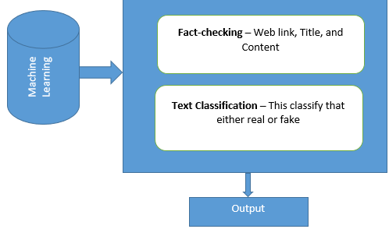
FIGURE 2. The flow of events above shows how we use machine learning for fake news detection.
POST-CONDISTIONS
After a user has entered their search data, the results will show underneath the search title whether it is false, or factual. After outputting the results, the system still allows the user to make more searches and it will still bring the results because there is no limit for the searches a user can make per entry.
We tested if the application is compatible with every device. We also performed a unit test because we will be testing individual functions or methods with objects to access the functionalities. We then tested the non-functional requirements such as performance, reliability, quality, security and maintainability.
The main aim of this project is to raise awareness about the impact of fake news across the country.

content
THE DETAILS
For our project firstly we had to give an overview of what is expected as the outcomes of our web application. We have designed wireframes also known as blue prints. A multimedia student used the pencil software to execute the activity before handing over to the programmers. Pencil is a free and open-source GUI prototyping tool that is quick, easily install and use to create mock-ups in popular desktop platforms.
For the GUI we used flask, which is a back-end for python. Flask is an API of Python that allowed us to build up web-applications. It makes use of a template language called Jinja2 which is used to create HTML, XML or other mark-up formats that are returned to the user via an HTTP request. Flask is a popular Python web framework, meaning it is a third-party Python library used for developing web applications.
For the GUI front-end we used HTML, JavaScript, Java, CSS and JSON. Front-end the parts of your web application which are intended to be used directly by the user’s browser. JSON is not mainly utilized; we just call some functions from it, it is used to store information in an organized, easy-to-access manner. JSON allows us to overcome the cross-domain issue.
Because there will be attackers that will try to hijack and modify data in transit from the client to the web server, for security measure we used application called web application firewall (WAF), it is described as a specific form of application firewall that filters, monitors, and blocks HTTP traffic to and from a web service. It analyses web traffic and blocks any attempt to exploit vulnerabilities such as cross-site scripting or code injection. It controls access to HTTPS server based on request by blocking or allowing. A WAF operates like a typical antivirus and antimalware, it looks for known patterns in the data stream and blocks it when it detects a malicious request it protects the organization from botnets, malware, and potential data exfiltration Input content of the article. We have used proxy firewalls, which operate at the application layer to filter incoming traffic between the network and the traffic source.
The implementation of HTTPS using SSL and TLS to provide secured communication on our web application. An SSL certificate is a type of digital certificate that provides authentication for a website and enables an encrypted connection. The SSL certificate is installed at server it use encryption algorithms to encrypt data in transit to prevent hackers to steal data sent over the connection between users and web. Used the public key to encrypt the data and session, to decrypt used the private key at the server.
RESULTS
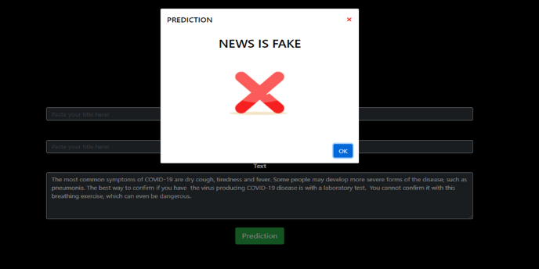
FIGURE 3. The picture above shows the returned output when the content of the news is captured on its specific field after the title is entered.
DISCUSSION
Initially we used the logistic regression algorithm because it was easy to use, but it only returned true results in all inputs whether the fake input was captured. We changed to passive aggressive classifier algorithm which returned false results whether the correct input was captured. We used TfidfVectorizer together with passive aggressive classifier algorithms.
We could not create the register and login page where a user was supposed to start before accessing the login page to access the main fact checking page because we had to create a different databases and algorithm to validate the login credentials. Now we only have the main page where the fake news detection happens.

CONCLUSION
In conclusion, we discovered that the problems of fake news play an important role in today’s life. This is because the advanced level of technology and communication methods have enabled information spreading among people without any verification. This is a reason why we started searching for solutions to stop fake news from spreading easily, we have acknowledged that fake news regarding COVID-19 will spread tremendously on social media. This is the reason why decided to build a web-based application to detect fake news about Corona Virus. However, it is well known that controlling the flow of information online is impossible.
In this project, we performed an attempt to verify the news articles credibility depending on their characteristics like verifying link, title and content or text. At this stage, we implemented an algorithm combining several classification methods with text models. It performed well, and the results were relatively satisfying.
As future work, we plan to better study the combination between the feature extraction methods and the classifiers as we will be able to choose the text representation model that performs best with the classifier. Moreover, to achieve a higher accuracy, we will have to implement a more high-level algorithm which may use data mining technologies with big data, because creating a big dataset including more types of news articles with more class labels will help raising the accuracy score.

REFERENCE(S)
- Perez-Rosas, V., Kleinberg, B., Lefevre, A., & ´ Mihalcea, R. (2017). Automatic detection of fake news. arXiv preprint arXiv:1708.07104.

